Name: _______________________

Joseph Banks Secondary College

Year 12 General Psychology

Assessment Task 1 – Test 1

52 marks (8% Response)

**OUTCOMES:**

|  |  |
| --- | --- |
| *Outcome 1:* | *Research Methods* |
| *Outcome 2:* | *Cognitive Psychology* |

**ALLOCATED TIME FOR THE TASK:**

* *You will have one period to complete the test in class*.

**INSTRUCTIONS:**

* *Attempt all questions*
* *No notes, files etc. to be accessed during the test*

|  |  |
| --- | --- |
| **Section One – Research Methods** | |
| Question 1 – Central tendency | / 7 |
| Question 2 – Ethical issues | / 5 |

|  |  |
| --- | --- |
| **Section Two – Short Answer** | |
| Question 3 – Information Processing Model | / 6 |
| Question 4 – Long-term memory | / 8 |
| Question 5 – Attention span | / 4 |
| Question 6 – Sensation and Perception | / 10 |
| Question 7 – Altered states of consciousness | / 12 |
| **Total** | **/ 40** |

|  |  |
| --- | --- |
| **Total Marks** | |
| Section 1 – Research Methods | / 12 |
| Section 2 – Cognition | / 40 |
| **Assessment Task 1 – Total Marks** | **/ 52** |

Teacher comment: ______________________________________________________________________________

________________________________________________________________________________________________________________________________________________________________________________________________________________________________________________________________________________________________________________________

**Research Methods**

**Question 1** (6 marks)

Researchers were interested in the relationship between exercise and life satisfaction. Data from six participants is shown in the table below.

|  |  |  |
| --- | --- | --- |
| **Participant** | **Hours of exercise per week** | **Life Satisfaction score** |
| 1 | 2.0 | 14 |
| 2 | 2.5 | 16 |
| 3 | 1.5 | 12 |
| 4 | 5.0 | 18 |
| 5 | 3.5 | 16 |
| 6 | 1.0 | 10 |

1. Calculate the following scores for Life Satisfaction. (4 marks)
   1. Mean 14.3
   2. Mode 16
   3. Median 15
   4. Range 8
2. This is an example of a correlational study, are correlational studies experimental or non-experimental? Why? (2 marks)

Non-experimental (1 mark) because they do not manipulate variables (1 mark).

1. What is a weakness of correlational research? (1 mark)

Does not equal causation.

**Question 2** (5 marks)

A teacher was curious how racism affects behaviour by conducting an experiment with her students, without telling their parents. She formed a blue-eyed group and a brown-eye group, informing them that the brown-eye group was superior to the blue-eye group. The brown eyed group had an increased self-efficacy in the classroom, as well as bullied the blue-eye group. Students in the blue-eye group lost self-efficacy and self-respect. The teacher used video footage to record behaviour and released this to the public.

1. Identify **two** ethical issues with this study. (2 marks)

No Informed consent to parents, no confidentiality (released to public), no right to withdraw OR psychological harm to bullied students. (1 mark per answer).

1. Identify the type of data used in this study. (1 mark)

Qualitative

1. Identify the independent variable. (1 mark)

Informing some students that they are superior.

1. Identify the dependent variable. (1 mark)

Self-efficacy OR Behaviour

**Question 3 (13 marks)**

1. Define the term operationalise. (1 mark)

To make a variable specific and measurable

1. Which type of research manipulates an independent variable and measures a dependant variable?

Experimental research

1. Which group in experimental research receives the independent variable? `. (1 mark)

Experimental group

1. What is the purpose of the control group in experimental research? (1 mark)

To compare the experimental group to to show cause and effect, or to have a baseline to compare behaviour to

1. For the following scenarios **operationalise** the independent variable for the experimental and control group and list three **relevant** potential extraneous variables. (10 marks)
2. Independent variable: Sleep Dependant variable: Attention span in maths class

|  |  |  |
| --- | --- | --- |
| Experimental group receives… | Control group receives… | Three potential extraneous variables… |
| Specifies an amount of sleep  e.g. 4 hours | No sleep | Stress  Distractions  Any 3 reasonable EV’s |

1. Independent variable: Alcohol Dependant variable: Aggression

|  |  |  |
| --- | --- | --- |
| Experimental group receives… | Control group receives… | Three potential extraneous variables… |
| Specifies a type and amount of alcohol  e.g. 1 glass of wine | No alcohol | Alcohol tolerance  Food consumption  Testosterone level  Any 3 reasonable EV’s |

**COGNITION**

**Question 3** (6 marks)

Analyse the Information Processing Model below.

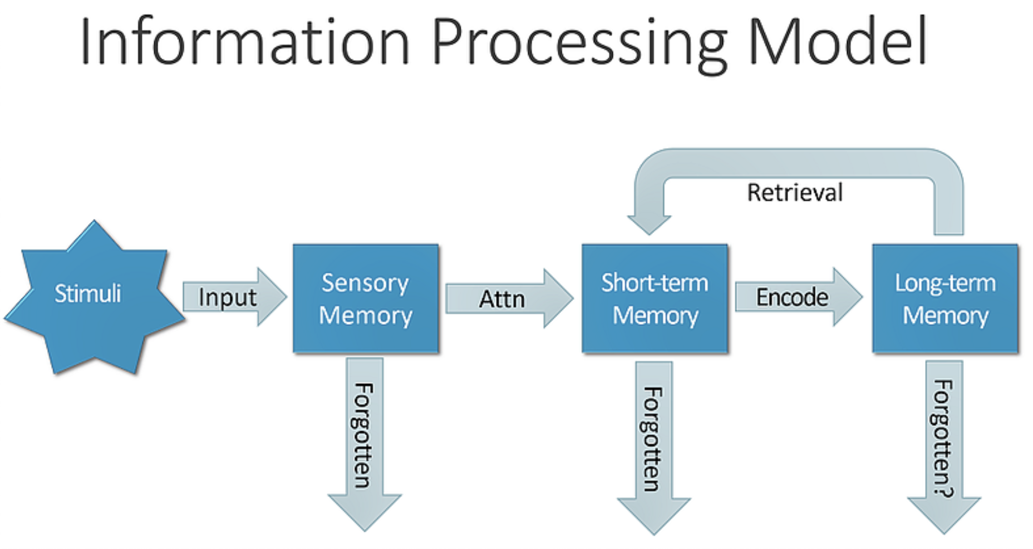

C

B

A

1. Identify A and B

a) Environmental stimuli (OR sensory stimuli OR incoming information) (1 mark)

b) Sensory memory or sensory register (1 mark)

1. What is the capacity and duration of B?

Capacity: Unlimited (1 mark)

Duration: 0.5 seconds (1 mark)

1. What is the capacity and duration of C?

Capacity: 3-7 pieces of information (1 mark)

Duration: 30 seconds (1 mark)

1. What is the capacity and duration of Long-term memory?

Capacity: Unlimited

Duration: Unlimited

**Question 4** (8 marks)

In order to log into a banking app, Sophie had to remember a 5-digit code she had saved in her notes app.

1. What method of rehearsal would Sophie use to recall the code 10 seconds after looking at her notes? (1 mark)

Maintenance rehearsal (1 mark)

1. After using this method successfully, Sophie decided to commit the code into long-term memory through elaborative rehearsal. Identify one strategy she could use to do this and why it is useful. (2 marks)

Mnemonic device, chunking, mind map OR recall (1 mark)

Useful to create more connections within your memory, categorise/chunk information into smaller parts OR actively recall information to strengthen the connection (1 mark).

1. Eventually, Sophie was able to type the code into her banking app automatically. It was as if her fingers knew what to do on their own. Identify and define this type of long-term memory? (2 mark)

Procedural memory (1 mark) – automatic ‘doing’ memory (1 mark).

1. Identify another type of long-term memory and provide an example. (2 marks)

Semantic – memory of facts about the world (1 mark).

Example – 2+2 = 4 (1 mark) (any reasonable answer)

**OR**

Episodic – memory of an event (1 mark).

Example – sitting this test (1 mark) (any reasonable answer).

**Question 6** (10 marks)

a) What does the term encoding mean in relation to memory? (1 mark)

Encoding refers to how information is changed and manipulated so that it can be stored in a memory store

b) Name and describe briefly the three main ways in which memory researchers measure how much information people remember. (6 marks)

Recall – retrieving information from LTM without a prompt (like short answer questions)

Recognition – recognising the correct answer from a list or with a prompt (like MCQ)

Relearning – how quickly it takes a person to learn information they have previously learned. If quicker the second time – they have retained some info from the first time.

Adam and Lucy chat for a whole and she says that they should stay in contant. Lucnh tells Adam that her telephone number is 0425 456 785. Adam does not have anything to write the phone number down on, so he tries to remember it.

c) Describe briefly one problem that Adam might have in trying to remember Lucy’s telephone number. Explain the reason why, referring to a feature of short-term memory. (2 marks)

Short-term memory has a limited duration of 30 seconds and a limited capacity of 5 – 9 pieces of info.

d) Outline two strategies that Adam could use to assist him in remembering Lucy’s telephone number. (2 marks)

Chunking the information into sections or elaborative rehearsal to try to link the numbers to meaningful LTM’s

**Question 7 (6 marks)**

a) Name and describe two slave systems of Baddeley and Hitch (1974) Working Memory Model and state their functions. (4 marks)

Visuospatial sketch pad: stores and processes information in a visual or spatial form.

Phonological loop: component that deals with spoken and written material.

Episodic buffer: It is a temporary store that integrates information from the other components and maintains a sense of time, so that events occur in a continuing sequence

b) Compare the working memory model with that of the multi-store model (2 marks)

|  |  |
| --- | --- |
| **Similarity** | **Difference** |
| Both show how information is manipulated and retained  Both are theories and models – thus no biological evidence for them  Accept any other correct reasonable response | MSM – shows how info moves from the external world to internal memory stores OR  MSM – shows the three different types of memory  WMM – only of the STM  WMM – explains how we manipulate information, can multi-task and compelte complex mental tasks |